# Question 5: Real-Time Predictive Analytics for Operations

**Festivals often operate on razor-thin margins. How is AI moving beyond simple historical analysis to enable genuine, real-time predictive analytics that festival organizers can use to forecast ticket demand, dynamically set pricing, and accurately allocate resources like food, beverage, and staffing?**

# Can AI Deliver Real-Time Predictive Analytics for Festivals?

Yes for crowd flow. Maybe for everything else, depending on whether sports venue success translates to multi-day outdoor festivals.

## 1. Real-Time Data Integration Replaces Historical Spreadsheets

Traditional festival analytics relies on historical spreadsheets and last year’s attendance numbers. AI vendors promise real-time data integration—POS systems, weather APIs, social sentiment tracking, competitor pricing—unified into a single data lake. No manual entry, no 3-7 day data lag. You’d know in real-time as patterns emerge, not a week after the festival.

That’s the promise. Here’s what actually changes.

Traditional analytics operates retrospectively. You compile data post-event, analyze historical trends, and produce static reports showing what happened. Static planning occurs 4-8 weeks before the festival based on gut feel and last year’s patterns. Decisions require vendor calls, contract revisions, manual spreadsheet updates—implementation takes days. The outcome: imprecise forecasts with significant inventory waste from overordering and stockouts.

AI-powered systems operate predictively. They continuously ingest real-time signals: ticket sales velocity (not just cumulative totals), secondary market pricing fluctuations, social media sentiment, weather forecast changes, artist streaming metrics, competitor event announcements. Multivariate forecasting models adjust hourly during the event—beer sales surge detected? The system triggers reorders in real-time, not weeks before based on outdated assumptions. Decision-making compresses to minutes through automated alerts integrated with vendor APIs.

Documented outcomes include 13x ROI (Legion WFM, Forrester-audited), 78% yield improvement (Cover Genius), and 66% scheduling time reduction (Legion).

Golden State Warriors demonstrates the scale of multivariate analysis traditional spreadsheets can’t match. Their system analyzes 50+ variables continuously—sales velocity, secondary market prices, weather, day-of-week, opponent strength, social sentiment—achieving 92% prediction accuracy. Sports venue success shows the technology works. Whether these specific metrics transfer to festivals is a separate question we’ll address.

Legion WFM processes 1.6 billion data points weekly while training 300,000 models. The system detects local events organizers didn’t know about, enabling proactive staffing adjustments. Event Dynamic operates a “stock market in real time” pricing model that learns the point of diminishing returns where price increases reduce attendance more than they improve revenue. Cover Genius’s behavioral data analysis identified price elasticity differences by event type: music concerts show high price sensitivity while sports demonstrate low sensitivity.

The distinction from traditional business intelligence is architectural, not incremental. Legacy dashboards compile historical data. AI systems ingest real-time signals and continuously recalibrate predictions to support immediate operational decisions. This shift—from “what happened?” to “what will happen next?”—enables proactive intervention before problems emerge.

This architectural transformation is real. Sports venues demonstrate it works. The question isn’t whether AI can transform analytics—it’s whether these systems, built for permanent stadiums with 40+ home games annually, work at multi-day outdoor festivals that run once or twice per year.

For one domain, the answer is definitively yes: crowd flow analytics has 50+ documented festival deployments with measured outcomes. For dynamic pricing, staffing optimization, and food waste reduction—the evidence gap between “works at sports venues” and “works at festivals” remains substantial.

## 2. Proven Festival Deployments

Only crowd flow analytics has substantial festival validation. Dynamic pricing, staffing AI, and food waste reduction have zero verified festival deployments as of 2025. Here’s what actually exists versus what vendors promise based on success elsewhere.

### Crowd Flow: Strongest Evidence

Crowd Connected runs at 50+ festivals annually including Coachella, Roskilde, Reading, Leeds, V Festival, Wireless, Latitude, and Goodwood Festival of Speed. Mobile app SDK combined with WiFi, Bluetooth, and GPS delivers real-time heatmaps. ML-based self-calibration requires no manual fingerprinting. Targeted push notifications based on location reduce emergency response times. This represents the most widely deployed festival-specific AI analytics system.

Roskilde Festival’s IBM partnership from 2015-2016 remains the most comprehensively documented deployment. The system collected 91-105 million tracking points from 44,206 unique tracked users, achieving a 74% opt-in rate. This wasn’t passive surveillance—festival-goers actively consented because they saw direct value. Analytics revealed concert attendance patterns, stage-to-stage movement flows, bottleneck identification, and weather correlation with crowd behavior and food consumption. Peak hour data showed 80 guests per toilet per hour during the 15:00-16:00 rush.

Latitude Festival demonstrated practical application. Targeted messaging based on crowd density generated a 7x engagement uplift compared to broadcast announcements. When areas approached capacity, the system sent personalized recommendations, and 28% of recipients attended suggested alternative acts. This isn’t theory—it’s documented behavioral change.

Crowd density follows physics regardless of venue type. High opt-in rates like Roskilde’s 74% show attendees accept the technology when value exchange is clear.

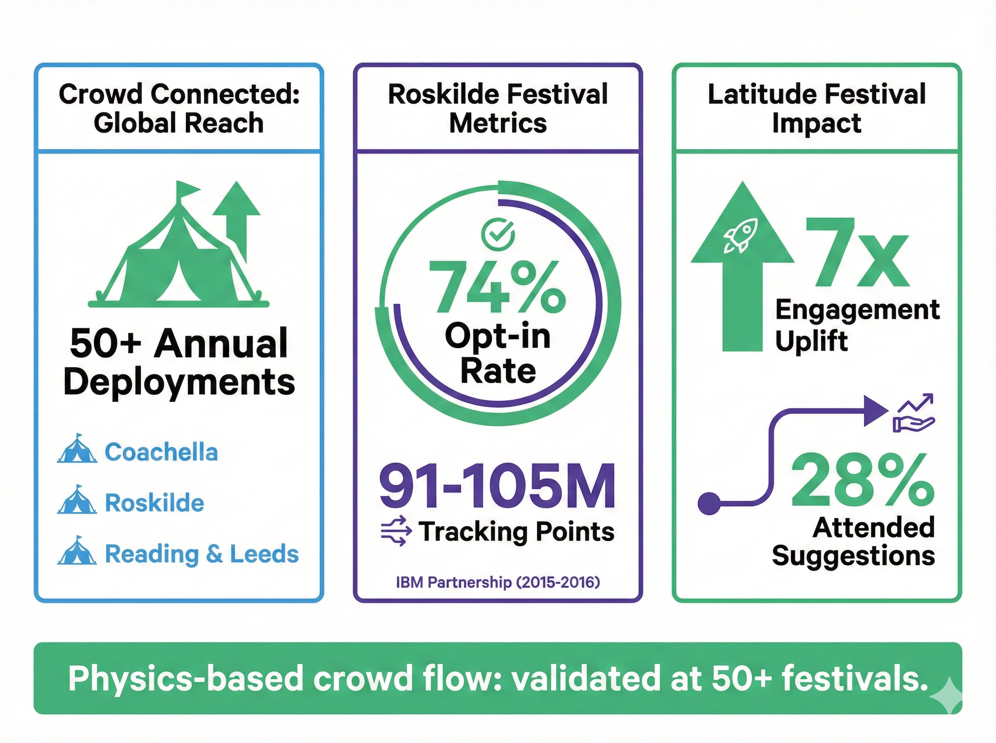 *Figure 1: Crowd Flow Analytics - Festival-validated deployments showing 50+ festivals annually, 74% opt-in rate at Roskilde, and 7x engagement uplift at Latitude.*

### Demand Forecasting: Emerging

DICE processes 50% of ticket sales via AI recommendations—not pricing optimization, but discovery. The platform matches fans with shows they’ll enjoy, serving 10 million monthly active users across 10,000+ venues and festivals representing 55,000+ artists. CEO Phil Hutcheon explicitly states the platform has “never had an artist approach us for dynamic pricing.” Fixed, transparent pricing remains the model. This proves machine learning can drive ticket discovery without touching pricing algorithms.

Tomorrowland analyzed pre-registration data from hundreds of thousands to inform capacity planning. Demand analysis led to expansion from one weekend to two, as patterns revealed demand substantially exceeding the original 50,000 capacity.

Roskilde’s IBM partnership analyzed food sales patterns by temperature, time-of-day, and weather—demand forecasting for inventory planning purposes. The system helped order appropriate quantities in advance. This wasn’t real-time waste tracking, and Roskilde published no waste reduction metrics.

### RFID Systems: Validated

Tomorrowland processes large-scale transactions daily via RFID wristbands. Real-time crowd flow data enables control room staff dispatch based on density patterns. The system handles predictive logistics for arrivals from 200+ countries, scaling shuttles, trains, and airport personnel based on arrival patterns. Access control and cashless payments integrate with crowd flow monitoring—a closed-loop system combining sensing technology with operational response.

That’s the festival-validated evidence. Crowd flow works at scale. Demand forecasting shows emergence. RFID systems handle logistics and payments reliably. For dynamic pricing, staffing optimization, and food waste reduction—the evidence comes from sports venues and controlled environments, not festivals.

## 3. Emerging Capabilities: Sports Success, Festival Adaptation Needed

Sports venues deliver impressive ROI. Festivals haven’t deployed these systems yet. The technology works—the question is whether sports venue success metrics translate to multi-day outdoor festivals.

### Staffing Optimization

Legion WFM’s Forrester-audited deployment achieved 13x ROI over three years: $7.44 million in benefits against $566,000 in costs. The platform processes 1.6 billion data points weekly to generate 1.2 million shifts, reducing scheduling time 66%. The differentiator: “Forecast model considered out-of-the-box things other products didn’t, such as local events we didn’t even know were happening.” Context: retail and hospitality clients including Cinemark, MattressFirm, and SMCP. Festival deployments: zero documented.

Simio Digital Twin tested 300+ scenarios for Acrisure Stadium security checkpoint staffing, achieving maximum wait times under five minutes across all gates. Ohio State University Stadium uses AI video analytics to identify bathrooms with 3x average traffic, triggering increased housekeeping.

What festivals use instead: PAAM provides recruitment portals and shift scheduling for Glastonbury, Reading, and Leeds—logistics and communication, not AI-driven demand forecasting.

### Food Waste Reduction

Winnow Solutions achieved up to 50% waste reduction within the first year using computer vision and smart scales. IKEA’s 23 UK and Ireland stores demonstrated 50% waste reduction generating £1.4 million in savings during 2018. Across 1,400+ sites, Winnow reports $43 million in cumulative food cost savings. Context: controlled indoor kitchens. Festival deployments: zero.

Kitro’s peer-reviewed validation published in *Waste Management* journal documented 23-51% food waste reduction across multiple hospitality establishments—the strongest academic validation in this category.

Leanpath achieved 35% waste reduction at UCSF Medical Center with $60,000 in savings over two years. Google prevented 4 million pounds of food waste since 2014.

What festivals use instead: Glastonbury composts 132-149 tonnes manually through volunteer crews. Bonnaroo diverted 180 tons via similar manual processes. Coachella donated 28 tons of surplus food in 2022 through partnerships requiring phone calls and truck coordination, not algorithmic matching.

### Physics-Based Crowd Prediction

NEC Corporation’s crowd behavior analysis predicts congestion 10 minutes in advance within a 20% margin of error. The system treats crowds as fluid-dynamic objects rather than tracking individuals, preserving privacy while enabling proactive intervention. Context: stadium deployments only, no verified festival implementations.

### Dynamic Pricing

Real Madrid increased matchday revenue 29% while making 3,000 price adjustments per match. Golden State Warriors achieved 27% revenue increase with 92% prediction accuracy across 50+ variables. Manchester United reported 22% higher ticket sales after AI detected 40% slower sales following a Champions League loss and auto-adjusted pricing.

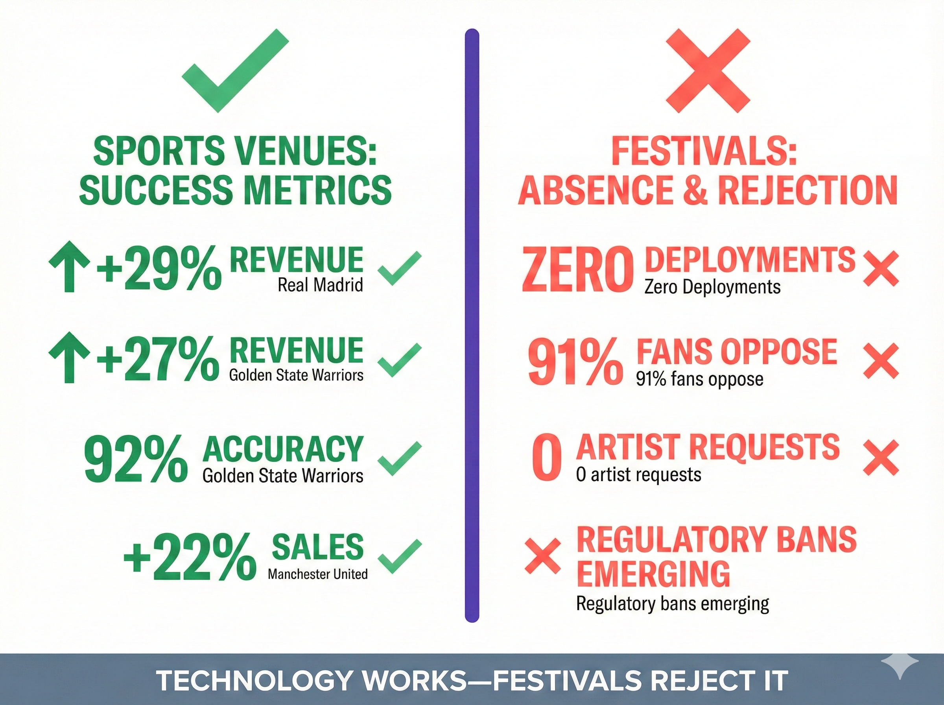 *Figure 2: Dynamic Pricing - Sports venue success metrics versus zero festival deployments.*

Festival reality: DICE CEO Phil Hutcheon states “we’ve never had an artist approach us for dynamic pricing.” Coachella and Glastonbury use manual tiering—$399 → $449 → $499 based on inventory thresholds set by humans, not algorithmic adjustments. Glastonbury explicitly rejects dynamic pricing to preserve fan goodwill.

Ticketmaster EMEA clarified in September 2025: “Every price is set by the event organizer. If prices change, it’s a human decision.” The Oasis controversy involved tiered pricing, not algorithmic surge pricing.

Regulatory headwinds: 91% of UK music fans oppose dynamic pricing. Australia is moving toward legislative bans. The UK government launched investigations after the Oasis reunion tour controversy.

## 4. Why the Evidence Gap Exists

Sports venues and retail stores succeed in different operational contexts than festivals. The technology works—the gap isn’t capability, it’s context. Here’s what makes stadiums different from festival fields.

**Stadiums are permanent. Festivals are temporary.** The stadium has climate control, year-round staff, and vendor relationships built over decades. You’re setting up tents for three days. The stadium refines its AI across 40+ home games per year, building the historical data machine learning needs. Your festival runs once, maybe twice annually, with attendance affected by factors that change every year: lineup strength, weather forecasts, economic conditions, competitor events.

**Stadiums have predictable patterns. Festivals don’t.** The stadium knows Tuesday nights draw smaller crowds than Saturdays, that certain opponents drive concession sales, that rain reduces attendance by X%. You know last year was sunny and this year predicts rain—but without decades of rain data, the AI can’t predict how this lineup’s fans behave when thunderstorms threaten.

**Retail optimizes independent systems. Festivals need integrated systems.** Retail schedules cashiers and stockers separately—optimizing one doesn’t affect the other. Your festival coordinates security, medical, and sanitation as an integrated system. When crowd density spikes, you need more security, more medical staff, and more portable toilets—simultaneously. An AI optimizing just one component creates safety gaps.

**Controlled kitchens work reliably. Outdoor festivals don’t.** IKEA kitchens have centralized waste tracking, reliable power, consistent temperature—conditions where AI waste detection works. Your food vendors operate in distributed zones where lighting changes hourly, generators fail, and temperature swings affect food safety.

This isn’t a technology limitation. It’s an operational context mismatch. The technology could adapt, but vendors haven’t demonstrated it at festivals yet.

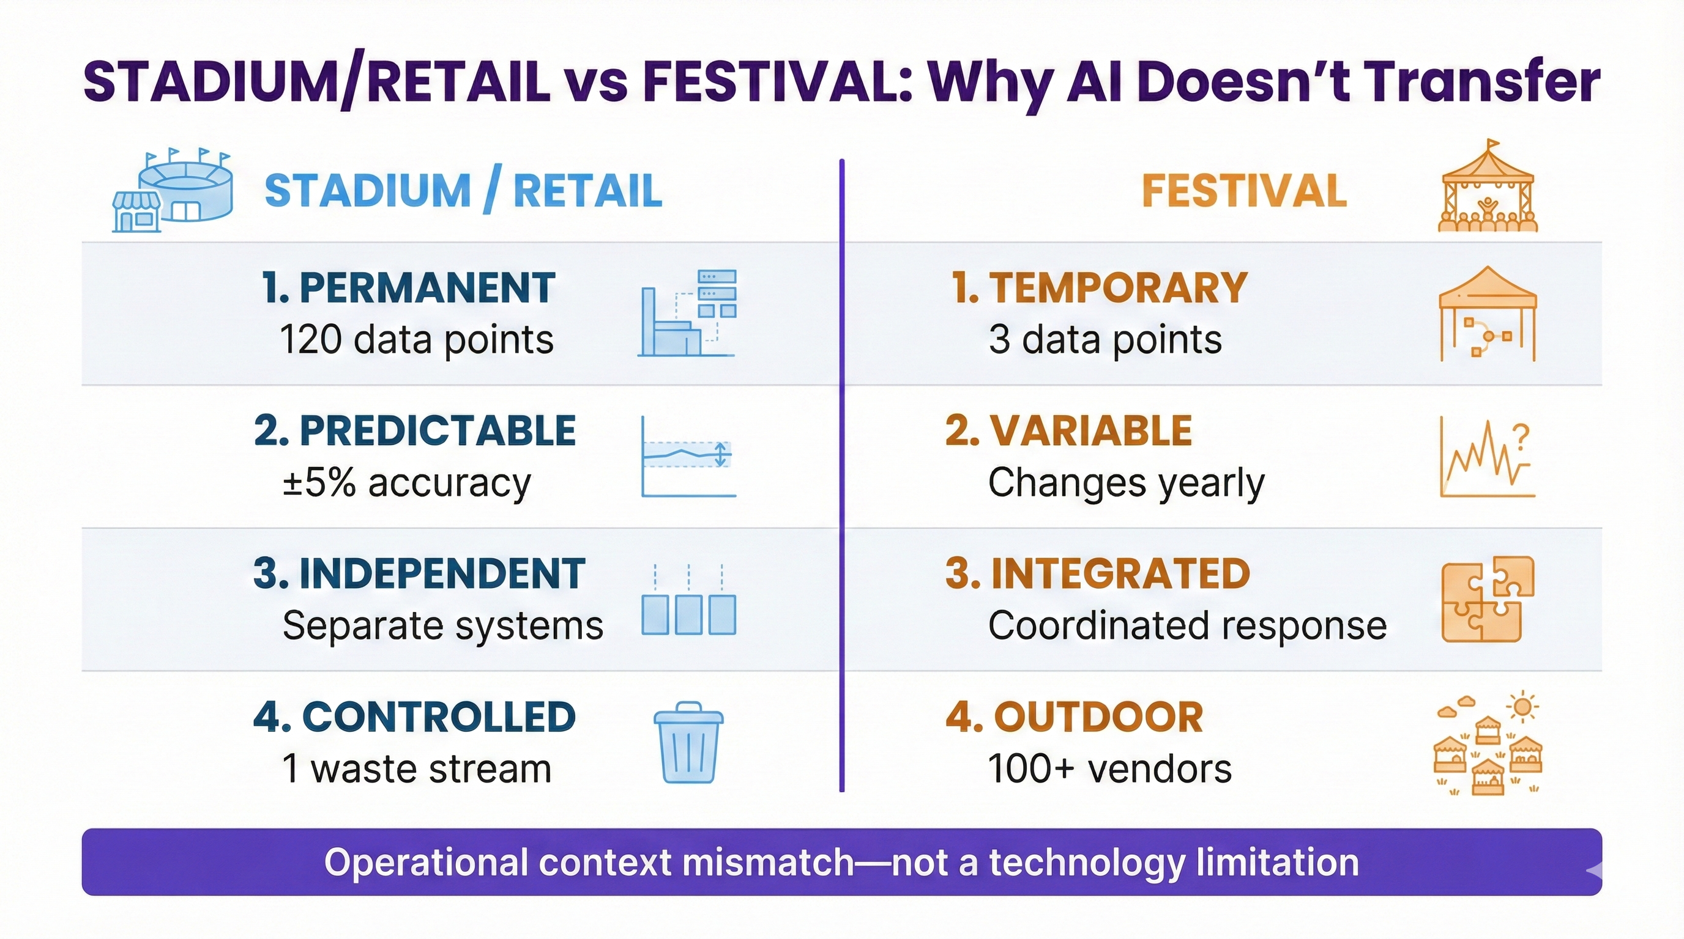 *Figure 3: Why AI Doesn’t Transfer - Four key operational differences between stadiums/retail and festivals that prevent direct technology transfer.*

Evidence transferability varies by domain. Crowd density physics transfers with HIGH confidence—NEC’s fluid dynamics principles apply universally regardless of venue type. Crowd flow monitoring works across both domains, as Crowd Connected’s deployments at both UEFA Champions League Final and Coachella demonstrate.

Dynamic pricing fundamentals transfer with MEDIUM confidence. Demand curves and price elasticity work conceptually. Modification is needed for no-baseline events: festivals run once or twice annually versus 40+ games, creating different data foundations. General optimization principles transfer, but specific ROI timelines and percentages do not.

Specific percentage claims transfer with LOW confidence. 50% waste reduction at IKEA ≠ 50% at festivals. Workforce ROI from permanent-employee contexts like Legion’s retail deployments ≠ three-day contract workers at festivals. Accuracy metrics achieved in stadiums may not reach the same precision in open-terrain outdoor environments.

## 5. Small Festivals: Complete Evidence Void

Zero documented AI analytics deployments exist at festivals under 10,000 attendees. The enterprise systems delivering impressive ROI at large scales don’t downscale gracefully.

Crowd Connected publishes custom pricing rather than standard small-event tiers, suggesting their business model targets larger deployments where per-attendee costs justify infrastructure investment. Legion WFM’s architecture processes 1.6 billion data points weekly—a data volume incompatible with small festival operations generating only thousands of transactions over three days.

The affordable alternatives lack the capabilities vendors pitch to large festivals. FIXR, Eventbrite, and ClearEvent provide essential ticketing and basic analytics—sales reports, demographic breakdowns, conversion tracking—but not AI/ML-powered demand forecasting, dynamic resource allocation, or predictive waste reduction.

The Association of Independent Festivals in the UK represents 150+ member festivals ranging from 500 to 76,000 capacity. Despite this range, the organization publishes no technology case studies demonstrating AI analytics deployments at smaller members. If validated implementations existed, AIF would likely promote them.

What does this mean for small festivals? As of 2025, there’s no validated pathway to AI analytics. The technology exists at enterprise scale. The need exists at small festival scale. But the economic model, data volume requirements, and infrastructure assumptions haven’t aligned to create viable solutions for events under 10,000 attendees.

## The Bottom Line

Deploy crowd flow analytics now. Crowd Connected and NEC (for controlled venues) have proven implementations. Physics-based density monitoring works across venue types. RFID systems for access control and cashless payments have demonstrated success at scale, with Tomorrowland handling logistics for arrivals from 200+ countries.

Pilot demand forecasting with appropriate caution. Roskilde’s IBM partnership demonstrated that food and beverage demand forecasting based on weather correlation and time-of-day patterns can improve inventory planning. DICE’s AI recommendation engine proves machine learning can drive ticket discovery without touching pricing—40-41% of their sales flow through AI-powered suggestions matching fans with shows they’ll enjoy. The architecture works. Festival-specific validation for broader forecasting domains remains limited.

Require festival validation before committing to dynamic pricing, food waste AI, or staffing optimization extrapolated from sports venues. Dynamic pricing faces regulatory risk (91% UK fan opposition, Australian bans emerging) and artist opposition that make sports venue ROI metrics irrelevant to festival decisions. Food waste AI has no documented outdoor festival deployments because the operational context differs too substantially from the controlled kitchens where the technology succeeds. Staffing optimization systems built for permanent retail workforces haven’t demonstrated the adaptations necessary for three-day contract workers operating integrated festival systems.

When vendors pitch impressive stadium metrics, your critical question remains: “Does your 78% yield improvement work at my multi-day outdoor festival with temporary infrastructure, or only at climate-controlled stadiums with permanent staff and years of historical data?”

The answer determines whether you invest wisely or join the organizations reporting zero ROI from AI implementations that didn’t deliver on promises optimized for different operational contexts. Festival professionals who master evidence transferability assessment protect their organizations from expensive mistakes while identifying the genuine opportunities where AI analytics already works.

**Sources:**

## Tier 1: Peer-Reviewed, Audited, Festival-Specific

* [IBM/Copenhagen Business School Roskilde Study (2015-2016)](https://asiagrowthpartners.com/case-study/copenhagen-business-school-drives-sustainability-at-roskilde-festival/) - 91-105 million tracking points, 44,206 unique tracked users
* [IBM Roskilde Technical Details](https://www.slideshare.net/HenrikHammer/roskildefestival-big-data) - Most documented festival crowd analytics deployment
* [Forrester Total Economic Impact Study - Legion WFM](https://legion.co/) - Audited 13x ROI, 1.6B weekly data points (retail/hospitality contexts only)
* [PRIMA Medical Staffing Model](https://ncbi.nlm.nih.gov/pmc/articles/PMC9962375) - Research-based prediction for festival patient presentations
* [Kumbh Mela Crowd Flow Research (2016)](https://www.sciencedirect.com/science/article/pii/S0952197621003171) - 13% improvement in crowd flow prediction via ensemble learning
* [Machine Learning for Catering Demand Forecasting](https://www.sciencedirect.com) - 14-52% reduction in wasted meals (canteen testing only, not festivals)

## Tier 2: Industry Publications, Vendor Case Studies

* [Crowd Connected - 50+ Festivals Press Release](https://www.crowdconnected.com/news/colocator-to-benefit-over-50-summer-festivals-in-2017/)
* [Crowd Connected - Latitude Festival Case Study](https://www.crowdconnected.com/case-studies/latitude-festival-case-study/) - 7x engagement uplift
* [UK Government Case Study - Crowd Connected](https://www.gov.uk/government/case-studies/crowd-connected-strikes-the-right-note-with-music-festivals)
* [IQ Magazine - Dynamic Pricing Investigation (September 2025)](https://www.iqmagazine.com/2025/09/dynamic-pricing-beyond-the-controversy/) - Ticketmaster EMEA clarification on human-set pricing
* [Ticket Fairy - AI Forecasting Analysis](https://www.ticketfairy.com/blog/forecasting-festival-attendance-using-ai-and-data-analytics-for-smarter-planning)
* [Ticket Fairy - Crowd Management Technology](https://www.ticketfairy.com/blog/crowd-management-tech-for-festivals-from-heat-maps-to-ai-monitoring)
* [PAAM Software Client List](https://www.paamapp.com/clients/) - Glastonbury, Reading, Leeds, Latitude, Parklife
* [Movement Strategies - Glastonbury](https://www.movementstrategies.com/case-studies/glastonbury-festival) - Crowd risk assessment since 2007
* [Meshh - Indoor vs Outdoor Analytics Comparison](https://www.meshh.com/2023/07/21/the-key-differences-in-spatial-analytical-data-collection-indoor-events-vs-outdoor-events/)
* [Glastonbury Sustainability Report](https://www.glastonburyfestivals.co.uk/information/sustainability/) - 132-149 tonnes food waste composted manually
* [Tomorrowland Sustainability](https://lovetomorrow.com/sustainability-journey/) - AI smart bins, 21% carbon footprint from food waste
* [Association of Independent Festivals](https://www.aiforg.com/about) - 150+ UK festivals (500-76,000 capacity)

## Tier 3: Sports/Hospitality Context (Not Festival-Validated)

* [NEC Corporation - Crowd Behavior Analysis](https://www.nec.com/en/global/rd/technologies/crowd/index.html) - Stadium deployments only
* [NEC Prediction Press Release](https://www.nec.com/en/press/201610/global_20161024_05.html) - 10-minute prediction, 20% margin
* [Winnow Solutions Case Studies](https://www.winnowsolutions.com/en/case-studies) - IKEA, hotels (controlled indoor kitchens)
* [Leanpath Case Studies](https://www.leanpath.com/case-studies/) - Hospitals, universities (non-festival contexts)
* [Legion WFM Case Studies](https://legion.co/blog/2024/06/12/case-studies-in-success/) - Retail/hospitality only
* [DICE Platform Information](https://variety.com/2024/music/dice-dynamic-pricing) - CEO statements against algorithmic pricing
* [Music Business Worldwide - DICE](https://www.musicbusinessworldwide.com) - “50% AI sales” refers to discovery/recommendations, NOT pricing

## Tier 4: Lightweight/Small Festival Options

* [FIXR Platform](https://fixr.co/) - Free for organizers; real-time dashboards (no predictive AI)
* [Eventbrite Features](https://www.eventbrite.com/blog/ai-tools-for-events/) - AI for event creation/marketing, NOT predictive operations
* [GetApp Festival Management Software Review](https://www.getapp.com/recreation-wellness-software/festival-management/) - Landscape of available tools